**奖学金申请流程Application Process**

1. 下载并填写申请表Download and Fill in the Application Form.

2.请按下述表格准备材料Prepare the required materials (refer to the following list)

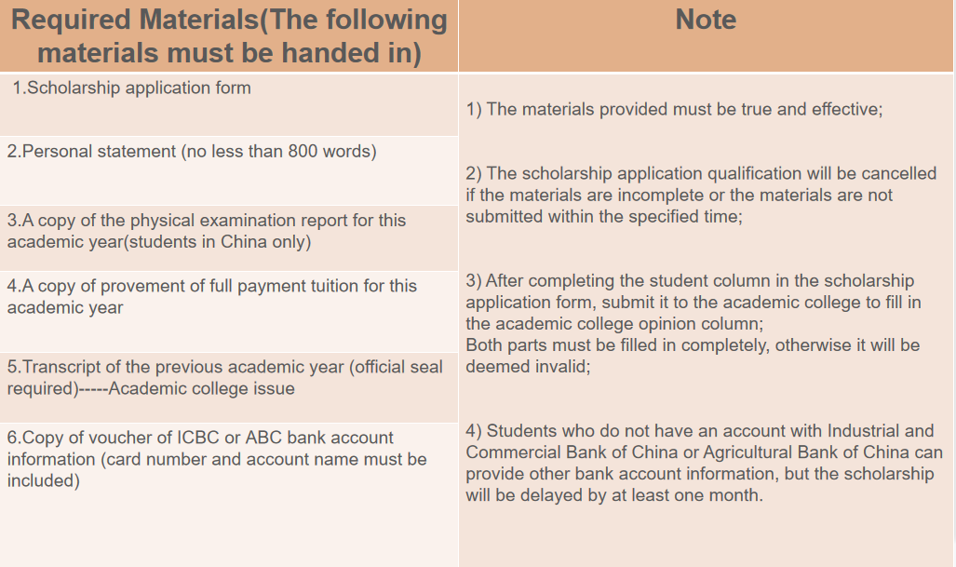

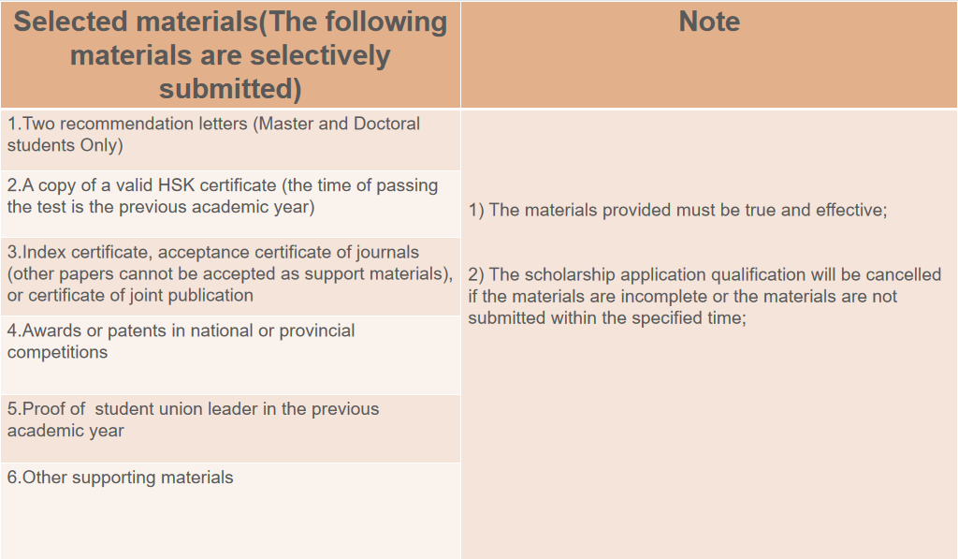

3.材料递交时间（The application time）：2024/10/8---2024/10/17(16:30).

4.材料递交方式：扫码登记申请信息，并按要求上传清晰的申请材料文件。如果申请材料图片模糊不清影响评审，一切后果由本人承担。

How to submit materials: Scan the QR code to register the application information, and upload application materials file as required. **If the picture of the application materials is blurred and affects the review, all consequences shall be borne by yourself.**

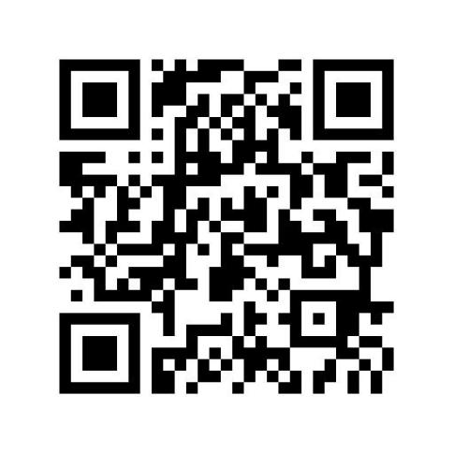

5.银行卡信息上传必须出具银行的回执，样本如下图。

For bank card information, you should upload clear photo of the bank's receipt which issued by bank and there shows your card No. And account name. The sample is as shown below.

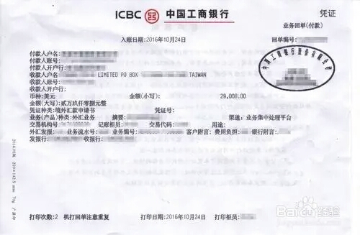

没有银行卡的同学可以暂时不上传，奖学金如何发放，相关老师会联系你。

Students who do not have a bank card can not upload it temporarily. The relevant teacher will contact you for how the scholarship is issued later.