浙江工业大学在读优秀学历留学生奖学金申请表
ZJUT Distinguished Degree Students Application Form
（ 2023 / 2024 ）年度Academic Year
Reminder 1：各类奖学金申请基本GPA要求,如不符合，请勿递交申请。
The basic GPA requirements for various scholarship applications. If you do not meet the basic GPA requirements, please do not submit the application.

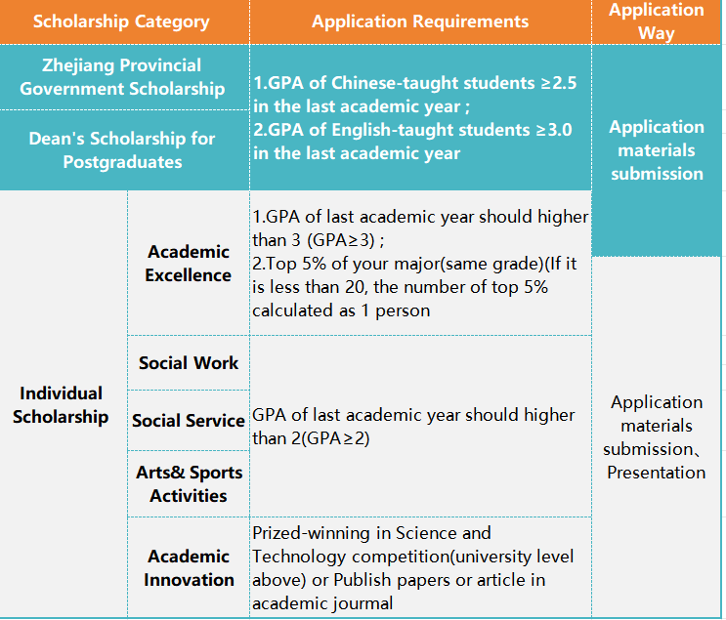
Reminder 2：表格填写说明Instructions
1.以下内容除了签字部分以外，均可用电脑输入。
The content can be input by computer except for the signature part.

2.学生须完成个人基本信息和自评填写后，再发给导师（研究生）或专业学院教学教务老师进行填写，否则无效。
Students must complete the basic personal information and self-evaluation, then send it to the tutor (postgraduate) or the teaching affairs teacher of academic college to fill in, otherwise it will be invalid.

3.境外学生在奖学金评审过程中，考勤和活动参与情况不纳入考评。
During the scholarship review process for students off China, attendance and participation in activities will not be included in the assessment.

4.以下信息必须如实填写，如有造假或篡改，直接取消奖学金申请资格。
The following information must be filled in truthfully. If there is any falsification or tampering, the scholarship application qualification will be canceled directly.

个人基本信息
Personal Information
中文名Chinese Name |  | 学号 Student No. |  | 照片 Passport-Sized Photo
护照姓名 Passport Name |  | 护照号码Passport No. |  | 照片 Passport-Sized Photo
性别Gender |  | 国籍Nationality |  | 照片 Passport-Sized Photo
学院 College |  | 专业 Major |  | 授课语言Teaching Language  □ Chinese  □ English  Select one and Mark √
学生类别Student type  □博士研究生Doctoral student  □ 硕士研究生Master  □ 本科生Bachelor | 申请奖学金类别（限选择两类）Scholarship Type（only choose two types）  □浙江省政府奖学金Zhejiang Provincial Government Scholarship  □硕博院长奖学金  Dean’s Scholarship for Postgraduates  □学业优秀奖学金Academic Excellence  □社会工作奖  Social Work  □社会服务奖  Social Service  □文体活动奖  Arts& Sports Activities  □学术创新奖  Academic Innovation |  | 上学年我的学习位置My Last Academic Year Location  □中国 China  □本国 My Country | 本学年学籍状态  Study Status  □Studying在读  □Suspension休学
自 评
Self-Evaluation
上一学年是否受到通报表扬或通报批评？  Whether got warning or praise in last academic year？  □受到通报批评Got Warning  □受到通报表扬Got Praise  □均无Nothing  如果有，请标明次数If yes, please indicate the number of times：_________________ | 上一学年是否担任社团职务？Did you had social duty in last academic year？  □学生社团主任/主席/部长级别Director/chairman/ ministerial level of Student Associations  □副主任/副主席/副部长级别 Deputy Director/ Deputy Chairman/ Deputy Minister level of Student Associations  □均无Nothing | 上一学年活动文化/志愿者/讲座活动参与情况（仅境内学生填写）  Participation in cultural/volunteer/ lecture activities in last academic year？ (Students in China need to fill in this part)  □I participated有  □I did not participate无  如果有，请标明次数If yes, please indicate the number of times：_______________ | 上一学年是否参加学校组织的比赛？Did you participate in a competition organized by the ZJUT in last academic year?  □I participated有  □I did not participate无  如果有，请标明获得奖项If yes, please mark the award：  _____________________
上一学年是否有HSK成绩？  Did you have HSK scores in the previous school year?  □I have有  □I do not have 我没有  如果有，请标明HSK等级  If yes, please mark HSK level you passed  __________________ | 承诺书  以上所填信息均为本人2023年9月-2024年8月期间的在校表现，所填信息真实无误。  如有造假，自动放弃本学年奖学金评选资格。  Commitment  The above information is my study performance from September 2022 to August 2023, and the information filled in is true and correct.  In case of fraud, the scholarship qualification for this academic year will be automatically waived.  Signature：  Date：
教师评
Teacher Recommendation

学生请勿填写以下内容Students please do not fill in the following contents.
导师推荐意见Supervisor Recommendation
(仅研究生填写This Part For Postgraduate Only )

上一学年学术情况及表现：

导师签字:
日期：
所在院系推荐意见The Opinion of Academic College
（仅本科生填写This Part For Undergraduate Only）

上一学年GPA(重考、补考不计入):

专业排名：

教学教务老师签字:
日期：
国际学院意见The Final Opinion of International College （此部分无须填写No Need to Fill Out）

评审意见：

负责老师签字:
日期:

